**Development of a Fully Responsive Modern UI/UX**

**Car Showcase Website**



**Hassan Suhaib Abbasi**

Reg No: AWKUM-21129829

**Shahbaz Ahmad**

Reg No: AWKUM-2115503518

**Hasnain Saleem**

Reg No: AWKUM- 2113310

**Supervisor**

**Dr. Amir Akbar**

***This thesis is submitted for the Degree of***

**Computer Science (BCS),**

**Department of Computer Sciences, Garden Campus,**

**ABDUL WALI KHAN UNIVERSITY MARDAN,**

**SESSION 2021-2025**

# 

# PROJECT APPROVAL

This Project Report title

**Development of a Fully Responsive Modern UI/UX**

**Car Showcase Website**

**By:**

**Hassan Suhaib Abbasi**

Reg No: AWKUM-21129829

**Shahbaz Ahmad**

Reg No: AWKUM-2115503518

**Hasnain Saleem**

Reg No: AWKUM- 2113310

**Has been approved for the award of BCS Degree**

**External Examiner:** _____________________________________

Dr. Ashraf Zia  
Lecturer

**Internal Examiner:** _____________________________________

Dr. Aamir Akbar  
Lecturer

**Supervisor:** _____________________________________

Dr. Aamir Akbar  
Lecturer

**Chairman:** _____________________________________

Dr. Nadeem Iqbal  
Associate Professor

# DECLARATION

I hereby declare that the work presented in this thesis, including the software developed and the accompanying report, is entirely my own original effort. It has been prepared under the guidance of my project supervisor, and no part of it has been copied or reproduced from any other source without proper acknowledgment.

I affirm that this work has not been submitted, in whole or in part, for any other degree or qualification at this or any other institution. I understand that any form of plagiarism or academic misconduct will result in disciplinary action as per university regulations.

I voluntarily transfer the copyright of this thesis and all related materials to **Abdul Wali Khan University Mardan** and confirm that I will not use this work for commercial purposes or financial gain.

Date: ____________________________

Signature: _____________________

Hassan Suhaib Abbasi

Reg No AWKUM-21129829

Signature: _____________________

Shahbaz Ahmad

Reg No AWKUM-2115503518

Signature: _____________________

Hasnain Saleem

Reg No AWKUM-2113310

# DEDICATION

I dedicate this thesis to my beloved mother, father, siblings, teachers, and friends and especially to my parents because of their selfless efforts in making our lives and whose inspiration is a source of strength to me, and their magnificent devotion and prayers which are like a strong shield in hard times.

# ACKNOWLEDGEMENTS

**In the name of Allah, the Most Gracious, the Most Merciful**, who blessed me with the strength, wisdom, and perseverance to complete this project. Without His guidance, this achievement would not have been possible.

Before delving into the details, I would like to express my deepest gratitude to those who supported me throughout this journey. First and foremost, I am profoundly indebted to my esteemed supervisor, **Dr. Aamir Akbar**, for his invaluable guidance, patience, and expertise. His insightful feedback and encouragement were instrumental in shaping this project.

I am also grateful to my friends for their unwavering support and motivation. Their enthusiasm and constructive discussions kept me on the right path.

Above all, I owe endless thanks to my beloved parents, whose constant prayers, sacrifices, and encouragement were the driving force behind the successful completion of this work. Their love and belief in me have been my greatest strength.

# ABSTRACT

The rapid digitization of the automotive sector has intensified the demand for efficient and user-friendly online platforms for vehicle information. This study details the creation and deployment of an advanced web-based Car Showcase system, developed using Next.js 13, TypeScript, and Tailwind CSS. The project offers a comprehensive response to the limitations of conventional car listing platforms by introducing enhanced search functionality, dynamic filtering options, and an intuitive, modern interface.

Emphasizing current best practices in web development, the system features server-side rendering, mobile-responsive layouts, and a modular, component-driven structure. With a strong focus on usability and performance, the platform delivers a streamlined experience for users seeking detailed vehicle data. This work contributes to the digital automotive landscape by providing a model for building scalable, maintainable, and accessible car information portals.

# **Table of Contents**

PROJECT APPROVAL i

DECLARATION ii

DEDICATION iii

ACKNOWLEDGEMENTS iv

ABSTRACT v

Table of Contents vi

List of Figures x

List of Tables xi

CHAPTER 1 1

INTRODUCTION 1

1.1 Project Overview 2

1.2 Problem Statement 3

1.2.1 Current System Limitations 4

1.2.2 Market Demands 5

1.3 Objectives 5

1.3.1 Primary Objectives 5

1.3.2 Secondary Objectives 6

1.4 Scope 7

1.4.1 Technical Scope 7

1.4.2 Functional Scope 8

1.5 Technology Stack Justification 9

1.5.1 Next.js 13 9

1.5.2 TypeScript 9

1.5.3 Tailwind CSS 10

1.6 Significance 10

CHAPTER 2 11

FEASIBILITY ANALYSIS 11

2.1 Introduction 12

2.2 Technical Feasibility 12

2.3 Economic Feasibility 12

2.4 Software Contribution 12

2.4.1 Introduction 13

2.4.2 Importance of Software Contribution 13

2.4.3 Types of Software Contribution 13

2.5 Software Design Process Model 14

2.5.1 Requirements Analysis 14

2.5.2 System Design 14

2.5.3 Implementation 14

2.6 Feasibility Study for Development of a Fully Responsive Modern UI/UX Car Showcase Website 15

2.6.1 Economic Feasibility 15

2.6.2 Operational Feasibility 15

2.6.3 Schedule Feasibility 15

2.7 Technical Feasibility Analysis 16

2.7.1 Hardware and Infrastructure 16

2.7.2 Software Technologies 16

2.7.3 API Management 16

2.7.4 Integration Capabilities 17

2.7.5 Security and Compliance 17

2.7.6 Performance and Scalability 17

2.7.7 Technical Support and Maintenance 17

2.8 Technical Feasibility 17

2.9 Operational Feasibility 18

CHAPTER 3 19

REQUIREMENT ANALYSIS 19

3.1 Introduction 20

3.2 Problem Scenario 20

3.2.1 Overall Description 20

3.3 Functional Requirements 21

3.3.1 Hero Component 21

3.3.2 SearchBar Component 22

3.3.3 CarCard Component Implementation 23

3.4 User Interface Design 26

3.4.1 Layout Components 26

3.4.2 Responsive Design 28

3.4.3 CustomFilter Component 28

3.5 Performance Optimization 29

3.5.1 Image Optimization 29

3.5.2 Server-Side Rendering (SSR) 30

3.6 Database Design 30

3.6.1 Data Models 30

3.6.2 API Integration 31

3.7 Non-Functional Requirements 32

3.7.1 Performance Requirements 32

3.7.2 Data Privacy 32

3.7.3 Disaster Recovery 32

3.8 Software Quality Attributes 33

3.8.1 Reliability 33

3.8.2 Usability 33

3.8.3 Maintainability 33

3.8.4 Performance Efficiency 34

3.8.5 Compatibility 34

CHAPTER 4 35

SOFTWARE TESTING AND DEPLOYMENT 35

4.1 Introduction 36

4.2 White Box Testing 36

4.3 Key Characteristics 36

4.3.1 Internal Knowledge 36

4.3.2 Code-Based Testing 36

4.3.3 Detailed Examination 37

4.4 Black Box Testing 37

4.4.1 External Perspective 37

4.4.2 Functional Testing 37

4.4.3 Input-Output Testing 37

4.5 Black Box Testing Techniques 38

4.6 Unit Testing 38

4.7 Integration Testing 38

4.8 System Testing 38

4.9 Alpha Testing 38

4.10 Deployment 39

4.10.1 Deployment Strategy 39

4.10.2 Deployment Process 39

4.10.3 Deployment Features 40

4.10.4 Production Environment 41

CHAPTER 5 43

Conclusion 43

5.1 Project Achievements 44

5.2 Challenges and Solutions 44

5.3 Future Improvements 45

5.4 Lessons Learned 45

References 46

# List of Figures

Figure ‎1.1 Car Showcase Website Homepage 2

Figure ‎1.2 Website Overview 3

Figure ‎3.1 Architecture 20

Figure ‎3.2 React component for the Hero section 22

Figure ‎4.6 Manufacturer selection component with type-to-filter 23

Figure ‎4.7 Search submit button with SVG icon 23

Figure ‎3.5 CarCard component 24

Figure ‎3.6 Vehicle display card 25

Figure ‎3.7 React button component 26

Figure ‎3.8 Tailwind CSS card component with responsive hover states 26

Figure ‎3.9 Navigation bar component with logo and sign-in button 27

Figure ‎3.10 Footer component 28

Figure ‎3.11 Responsive Hero section styling using Tailwind CSS utilities. 28

Figure ‎3.12 Filter selection component with animated options 29

Figure ‎3.13 Optimized car image rendering 29

Figure ‎3.14 Server-side data fetching with dynamic query parameters in Next.js 30

Figure ‎3.15 TypeScript interface for car properties. 31

Figure ‎3.16 API call function to fetch filtered car data. 31

Figure ‎4.1 Git init and first commit commands 39

Figure ‎4.2 Command to link the local project to a Vercel account 39

Figure ‎4.3 Vercel env variable setup commands. 40

Figure ‎4.4 Command to build the project for production 40

Figure ‎4.5 Command to deploy the application to production using Vercel 40

# List of Tables

Table ‎5.1 Challenges encountered during development and the corresponding implemented solutions 44

# 

## INTRODUCTION

## Project Overview

In today's rapidly evolving automotive market, consumers face an increasingly complex decision-making process when researching vehicles. The Car Showcase application addresses this challenge by providing a comprehensive, user-friendly platform for accessing and comparing vehicle information. This project represents a significant advancement in how users interact with automotive data online.

The application leverages modern web technologies to create an intuitive and responsive interface that adapts to various devices and user preferences. By implementing advanced search and filtering capabilities, the system enables users to quickly find relevant vehicle information based on multiple criteria, including manufacturer, model, year, and fuel type.

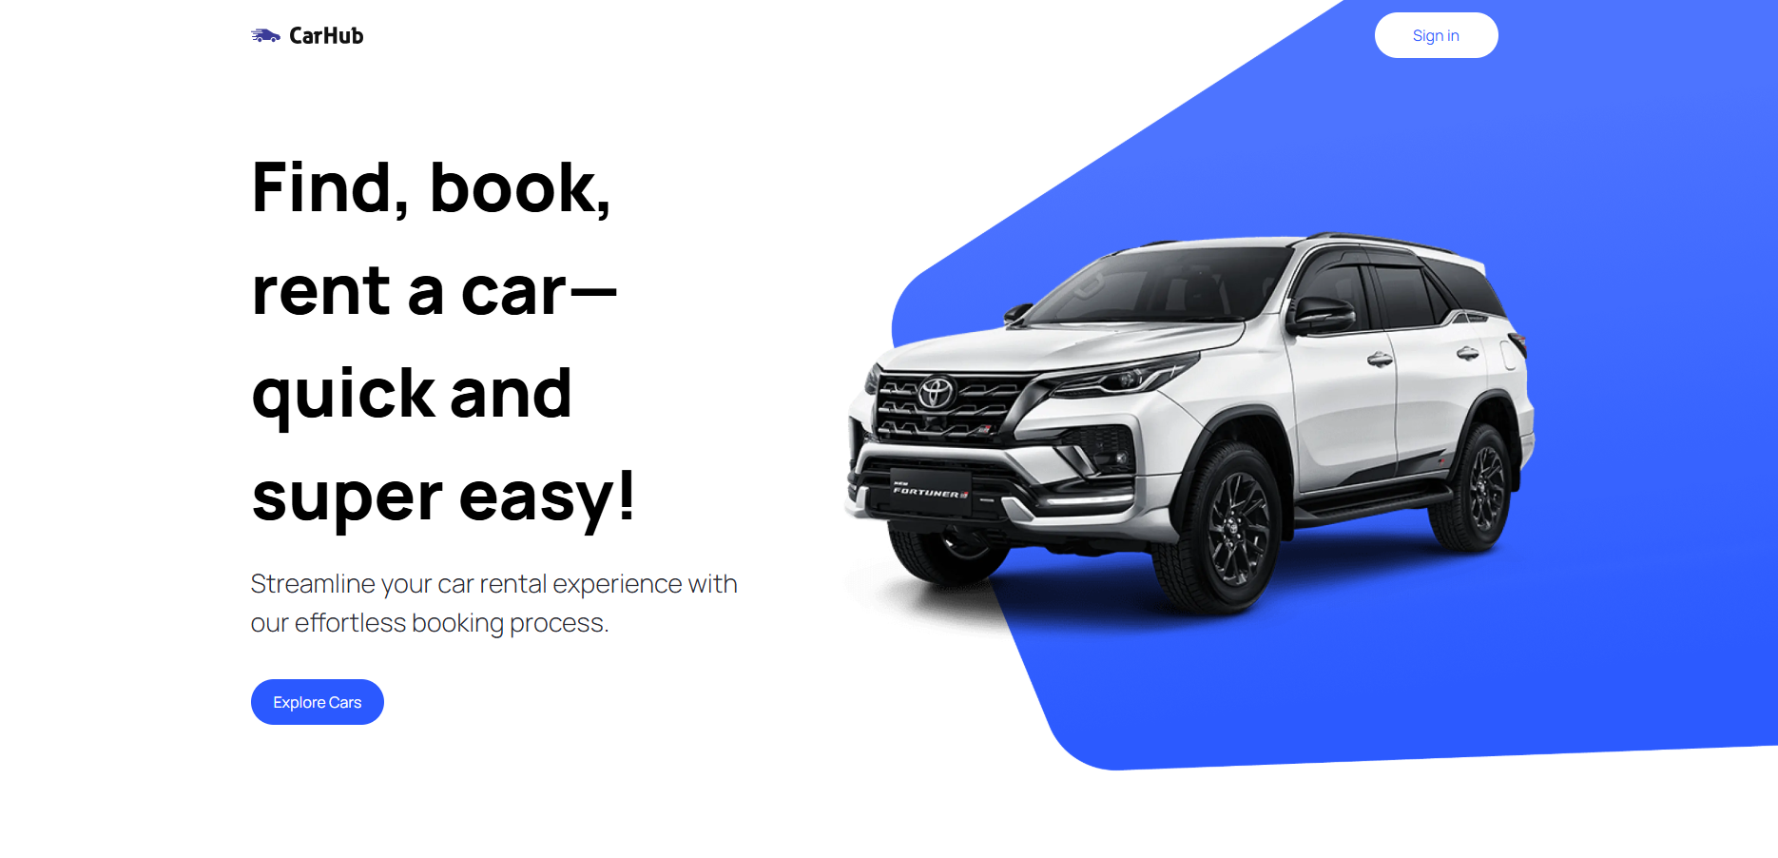

Figure . Car Showcase Website Homepage

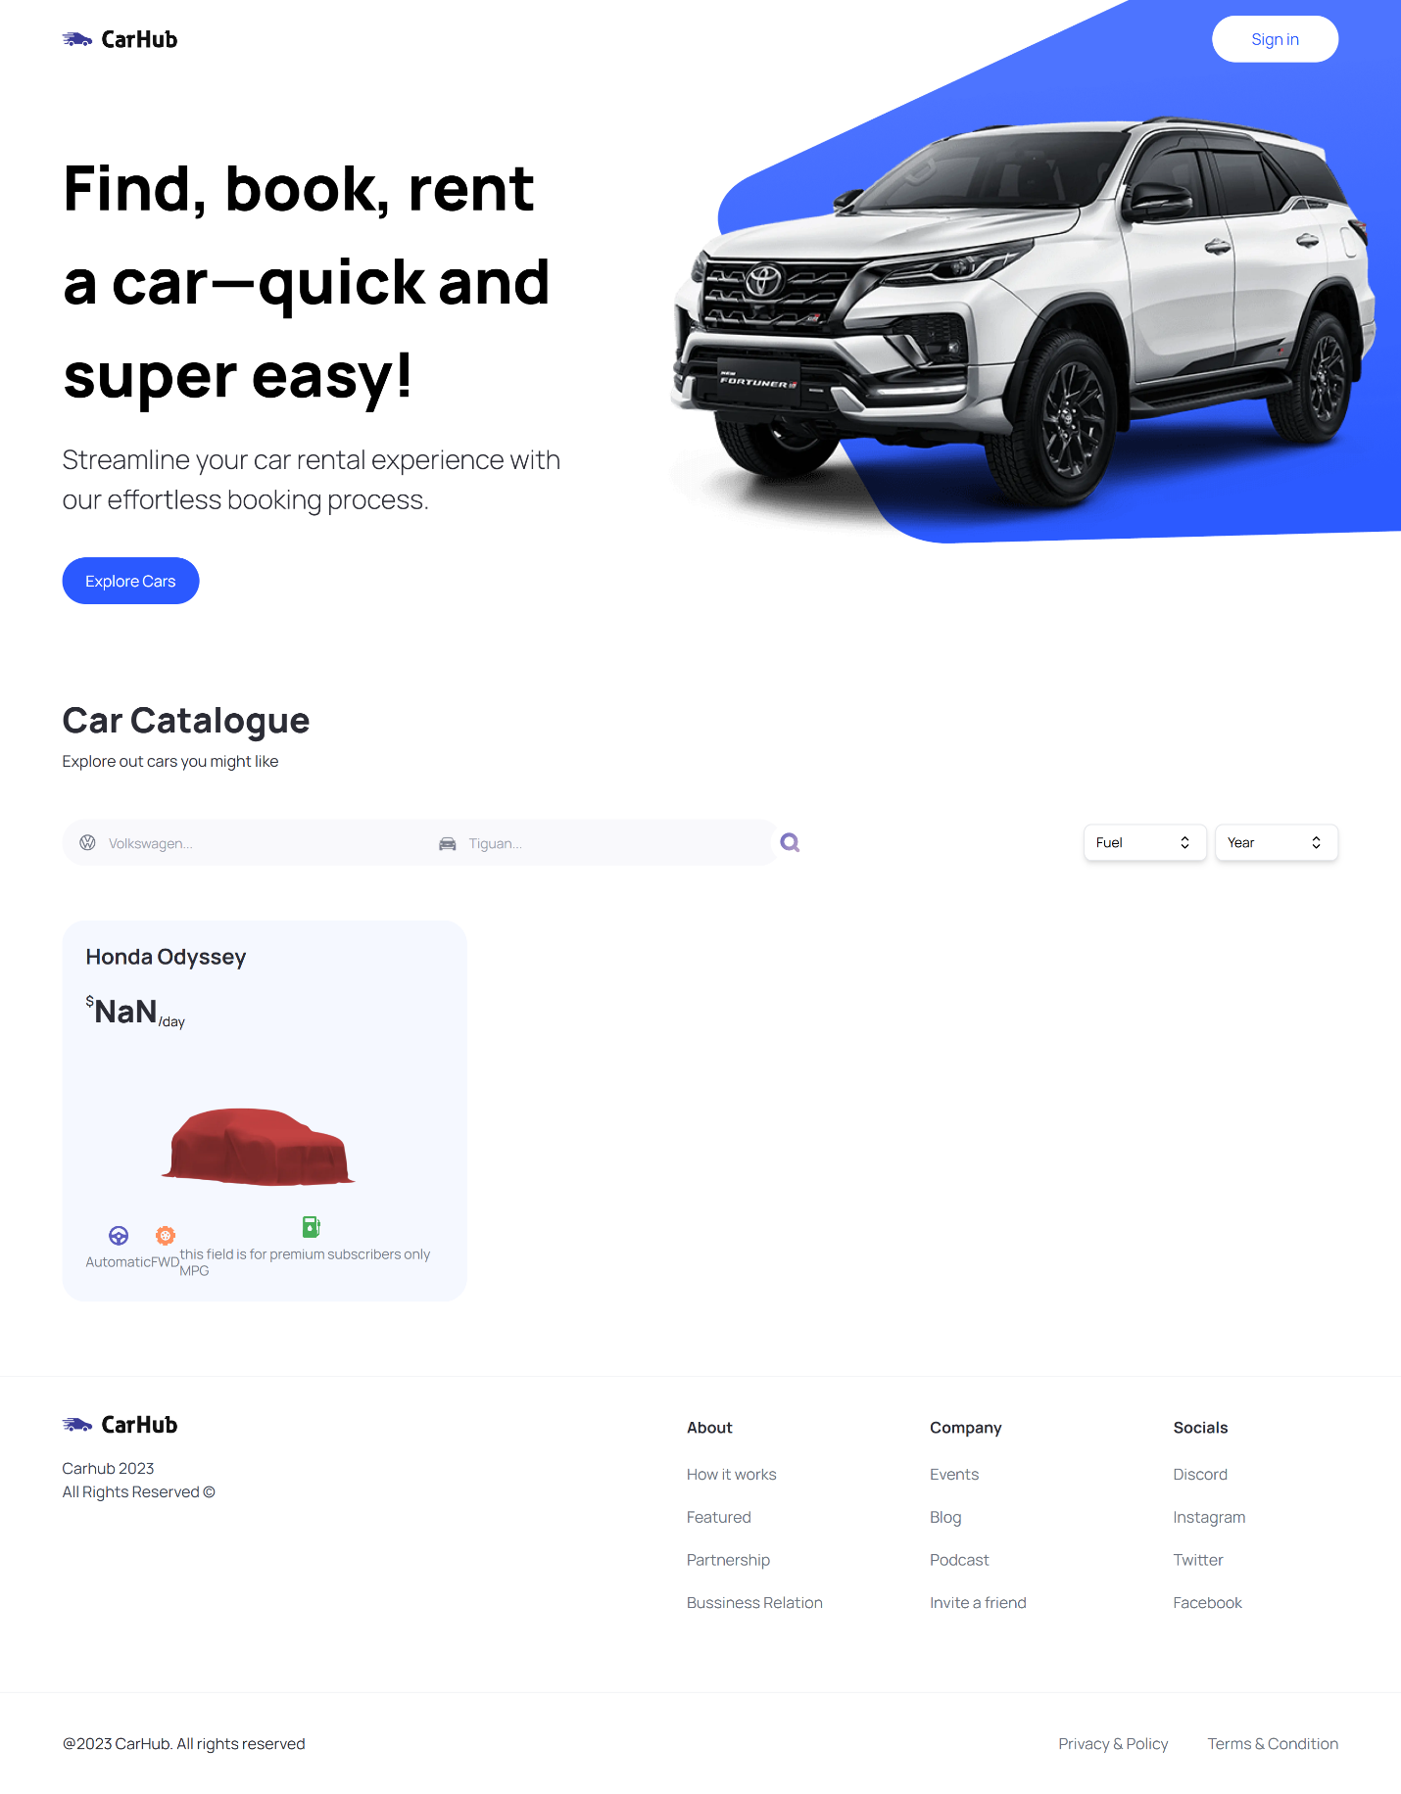

Figure . Website Overview

## Problem Statement

The automotive information landscape faces several critical challenges that impact user experience and decision-making:

### Current System Limitations

Standard vehicle information systems also have a number of drawbacks that limit their utility:

1. **Typical User Experience Problems with Current Platforms**

Due to a number of typical problems, many customers believe that using the current vehicle browsing platforms can be frustrating. To begin, the navigation menus are frequently overly complex, making it more difficult than necessary to merely peruse the available alternatives. Furthermore, the interface's general design and organization can be perplexing, particularly for inexperienced users who are merely attempting to find their way around. Additionally, vehicle details are frequently presented inconsistently across pages, which can make listing comparison challenging. It isn't any easier for mobile users because a lot of these platforms are cumbersome and don't respond well on smartphones or tablets. Users are regularly shown results that are either hard to filter or simply irrelevant, even when they try to search for a specific term.

1. **Technical Constraints**

The functionality and performance of several current platforms are another source of frequent annoyance for users. A user's patience may soon be tried because pages frequently take too long to load, particularly while viewing several listings. Performance often deteriorates significantly more when viewed on smartphones or tablets, giving the impression that the experience is unresponsive and slow. Users are unable to delve deeper or meaningfully refine their queries due to the often very rudimentary search capabilities. There are frequently few advanced filtering options available, which makes it challenging to focus results on what a user is truly seeking for. Furthermore, inadequate picture processing can result in sluggish loading graphics or badly presented images, which detracts from the overall surfing experience.

1. **Problems in Information Organization**

Some platforms struggle to organize their content. Users are frequently confused or frustrated because the layout is not organized in a way that allows them to easily find what they're looking for or move between parts. When information is provided inconsistently, it can lead to misunderstandings and make the platform appear less trustworthy. Comparing various automotive options is particularly difficult because the tools provided for side-by-side comparisons are typically limited or difficult to use. Furthermore, the lack of a clear information hierarchy makes it difficult to determine which facts are most important, leaving consumers unclear of where to focus. Poor categorization exacerbates the problem, making the browsing experience feel cluttered and time-consuming.

### Market Demands

A perfect car-browsing platform should be easy to use, educational, and seamless throughout. Instant access to thorough information about every car should enable users to make well-informed judgments free from confusion or needless clicks. In order for consumers to rapidly reduce the number of alternatives depending on their individual requirements and preferences, sophisticated search and filtering tools are necessary. In order to guarantee that the platform functions flawlessly on smartphones and tablets, a mobile-friendly interface is also essential. Users always get the most recent information since real-time updates help keep listings relevant. In addition to thorough information, excellent car photos are crucial for generating attention and confidence. It should be simple to compare many cars side by side using comparative analysis tools to aid in decision-making.

## Objectives

The project will overcome these challenges by pursuing the following main objectives:

### Primary Objectives

1. **User Experience Enhancement**

To improve the overall user experience, a number of essential improvements should be emphasized. First, creating an easy navigation system can help consumers travel about the site more easily and discover what they're looking for without confusion. Implementing responsive design concepts is also necessary to ensure that the platform appears and works properly on all platforms, from computers to smartphones. Consistency in the presentation of content across all pages enhances the site's professionalism and makes it easier for users to understand and compare listings. Given how many people use these sites on their phones, optimizing the mobile experience is critical. Finally, simplifying search functionality can dramatically reduce user irritation by providing more relevant and accurate results faster.

1. **Technical Performance**

Several technical changes should be implemented to provide improved performance and faster user interactions. Implementing efficient server-side rendering can drastically improve page load times and speed up content delivery to consumers. Optimizing how images are loaded and cached reduces delays and ensures that graphics show smoothly without compromising speed. Improving the speed and precision of the search feature is also crucial, as people demand immediate and relevant results when surfing. Improving data retrieval techniques can help reduce wait times while loading vehicle information or search results. Additionally, lowering server response latency is critical in delivering a faster, more responsive experience that keeps users interested and satisfied.

1. **Feature Implementation**

The platform should concentrate on improving its search features in order to provide a more smooth and interesting browsing experience. Strong, real-time filtering systems that enable users to rapidly reduce their options according to certain preferences are very beneficial to them. Users are also assisted in making certain, knowledgeable judgments when comprehensive car information is presented in an orderly and understandable way. By ensuring that images load rapidly and retain their excellent quality across the platform, image optimization improves both use and appearance. Last but not least, cross-device compatibility guarantees that customers will always have a dependable and consistent experience whether using a desktop computer, tablet, or smartphone.

### Secondary Objectives

1. **System Architecture**

In terms of development, creating a scalable and well-structured platform requires using a modular component design. This method not only streamlines the application's structure but also makes it simpler to maintain and upgrade certain components without impacting the system as a whole. Because clear, organized code makes it easier for future developers to comprehend and work on the project effectively, it is equally crucial to ensure code maintainability. This objective is supported by the establishment of comprehensive and understandable documentation, which offers instructions on how to use the system and contribute to it. Optimizing the build process improves efficiency and speeds up deployments, while creating reusable components increases uniformity throughout the platform while saving development time.

1. **Data Management**

The implementation of effective data management techniques is crucial for maintaining a dependable and high-performing platform. Implementing efficient data structures can greatly improve how quickly and smoothly the system processes and accesses information. Optimizing API integration is also crucial, as it ensures seamless communication between the frontend and backend, resulting in faster response times and better user interactions. Maintaining data consistency throughout the platform helps prevent errors and confusion, especially when users are comparing or saving information. Introducing effective caching strategies further enhances performance by reducing the need to repeatedly fetch the same data. Lastly, maintaining data integrity is vital to ensure that all information remains accurate, secure, and trustworthy across the system.

## Scope

The development project consists of an extensive framework of technical properties and functional functionalities abilities:

### Technical Scope

1. **Frontend Development**

The platform's development makes use of best practices and contemporary technology to guarantee customer pleasure, performance, and maintainability. The project gains access to capabilities like server-side rendering, routing, and enhanced performance right out of the box by utilizing **Next.js 13**. By adding type safety to the codebase, **TypeScript** integration enables developers to identify issues early and maintain a more reliable and scalable application. In order to provide a consistent experience on PCs, tablets, and smartphones, a **responsive design** makes sure the platform adjusts fluidly across various screen sizes. Building and maintaining the user interface is made simpler by the improved code reuse and organization made possible by the usage of a well-structured **component** architecture. Furthermore, efficient **state management** guarantees that information moves freely across the program, facilitating real-time updates and dynamic interactions.

1. **Backend Integration**

Backend development must be carefully considered in order to create a platform that is reliable and effective. In order to provide smooth connection between the frontend and backend and enable effective data retrieval, updating, and display, **API development** is essential. A carefully considered database architecture supports both performance and dependability by ensuring that data is stored in a scalable and organized manner. By providing users with pre-rendered pages, **server-side rendering** increases loading speed and enhances SEO performance. Simultaneously, as data or traffic increases, continuous **performance optimization** keeps the program responsive and quick. Last but not least, robust **security implementation** is necessary to safeguard user data and stop possible vulnerabilities, guaranteeing a secure and reliable experience for every user.

### Functional Scope

1. **User Interface**

Several significant UI improvements were added to make the platform more intuitive and user-friendly. The search option enables customers to rapidly locate vehicles based on certain keywords or criteria, making browsing faster and more efficient. Complementing this is a powerful filtering system that allows users to narrow down results based on numerous factors such as price, brand, or model, allowing them to conveniently focus on what is most important to them. Each listing contains a complete vehicle details display that provides all relevant information at a glance. A visually appealing and dynamic image gallery provides customers with a clear perspective of each vehicle, increasing their confidence in evaluating possibilities. Finally, a well-structured navigation system allows users to navigate seamlessly between portions of the platform, making the entire experience easy and pleasurable.

1. **Data Management**

The platform's backend is built with a number of important elements in mind to facilitate a seamless and effective user experience. The organization of vehicle information storage makes ensuring that all pertinent data is correct, current, and readily available. Search optimization strategies are used to increase the speed and precision of user queries, enabling prompt and accurate results delivery. Finding cars that fit their individual demands is made simpler by a versatile filter design that guarantees consumers can quickly refine their searches. Furthermore, without compromising performance, image optimization makes sure that pictures load rapidly and display beautifully on all devices. The platform operates smoothly even when heavily used thanks to efficient cache management that lowers pointless data requests and speeds up content delivery.

## Technology Stack Justification

The technology stack was selected to align with modern development standards while addressing the core needs of performance, scalability, and developer productivity.

### Next.js 13

Because of its extensive feature set and support for hybrid rendering techniques, Next.js 13 was selected for this project. This makes it the perfect framework for creating contemporary online applications. Its smooth integration of static generation and server-side rendering (SSR) is one of its best features; it enables developers to strike a balance between flexibility and performance based on the particular requirements of each page. Its file-based routing approach eliminates the need for complicated settings by making navigation setup simpler. Furthermore, Next.js has built-in support for API routes, allowing for seamless backend integration without the need for additional servers. Another useful feature is native image optimization, which aids in the rapid and effective delivery of media—a crucial aspect of user experience. Additionally, the framework provides complete TypeScript support, guaranteeing type safety and codebase maintainability. All things considered, Next.js 13 is especially well-suited for creating responsive, search engine optimization-friendly apps that can grow with user and corporate needs.

### TypeScript

By including static type declarations, TypeScript improves JavaScript and provides a number of benefits that are particularly useful for large-scale software projects. Its capacity to minimize problems through compile-time checks, which aid developers in identifying mistakes early in the development process, is one of its main advantages. Complex codebases are more organized as a result, which facilitates code management and allows it to grow over time. By facilitating more precise tools support and smarter autocompletion, TypeScript also increases developer productivity. By imposing a uniform structure and well-defined interfaces, it also makes it easier for development teams to collaborate. These advantages result in more maintainable code, particularly for projects that undergo substantial growth or evolution. TypeScript's type safety capabilities are essential for reducing the likelihood of runtime mistakes in large programs, which eventually results in more dependable and stable software.

### Tailwind CSS

Because of Tailwind CSS's effective development process, low learning curve, and deterministic design approach that promotes consistency and speed, it was selected for this project. Developers may style elements right within the markup thanks to its utility-first approach, which speeds up design and eliminates the need to transfer between HTML and CSS files. Faster iterations throughout development and increased developer productivity result from this. Tailwind encourages a unified design language throughout all elements, resulting in a sleek and unified experience. Additionally, it incorporates responsive design concepts, which guarantee that the application functions well on a variety of screen sizes. Because of the framework's adaptable customization possibilities, developers can modify UI elements to better reflect the visual identity of the business.

## Significance

The current project was constructed with a particular emphasis on best practices and contemporary web development standards. It uses modern frameworks and technologies to guarantee maintainability, scalability, and efficiency. User experience optimization is given a lot of attention with the goal of developing an engaging and user-friendly interface that caters to a wide range of user needs. Several performance optimization strategies are used concurrently to make sure the platform is responsive and quick even when there is a lot of traffic. Additionally, the project uses responsive design, which enables smooth operation on all kinds of devices, including smartphones and desktop computers. A more dynamic and accessible application is produced by enhancing SEO and improving initial load times through the use of server-side rendering techniques.

# 

## FEASIBILITY ANALYSIS

## Introduction

The feasibility analysis for the Car Showcase Website project is a comprehensive evaluation of the project's viability from multiple perspectives. This chapter examines various aspects of feasibility, including technical, economic, and operational considerations. The analysis aims to determine whether the project can be successfully implemented while meeting its objectives and constraints. Through this analysis, we establish a foundation for understanding the project's requirements, challenges, and potential solutions.

## Technical Feasibility

Technical feasibility assessment focuses on evaluating whether the proposed Car Showcase Website can be developed using current technology stack and available resources. This analysis considers the technical requirements, including the use of Next.js 13, React, and modern web development practices. The assessment confirms that the required technologies are well-established, widely supported, and suitable for creating a responsive and interactive car showcase platform. The technical stack chosen provides robust features for server-side rendering, efficient state management, and optimal performance.

## Economic Feasibility

The economic feasibility study examines the financial viability of the Car Showcase Website project. This analysis considers development costs, including software licenses, hosting services, and potential maintenance expenses. The project utilizes open-source technologies and cloud-based services, which helps minimize initial investment while maintaining high-quality standards. The cost-benefit analysis indicates that the project's benefits, including improved user experience and potential market reach, justify the investment in development and maintenance.

## Software Contribution

The development of the Car Showcase Application provided valuable hands-on experience with modern web technologies and methodologies. Through this project, practical knowledge was gained in utilizing Next.js for building performant, scalable applications with server-side rendering capabilities. The implementation process highlighted the importance of performance optimization techniques, particularly in rendering efficiency and asset delivery, which significantly improved the application's loading speeds and responsiveness.

A modular component-based architecture was employed, emphasizing reusability and maintainability, which streamlined development and enabled consistent UI implementation. The adoption of TypeScript proved instrumental in enhancing code quality, catching potential errors during development, and facilitating better collaboration through explicit type definitions.

The project maintained a strong focus on user experience, prioritizing intuitive navigation, accessibility standards, and responsive design principles. These development insights not only contributed to the successful delivery of the application but also established best practices that will guide future projects and professional growth in web development. The experience underscored the effectiveness of combining modern frameworks with thoughtful architecture and user-centric design.

### Introduction

Software contribution in the context of this project encompasses the various components and technologies that work together to create a seamless car showcase platform. This section examines how different software elements contribute to the overall functionality and success of the website. The integration of various software components enables features such as real-time search, filtering, and responsive design.

### Importance of Software Contribution

The significance of software contribution in this project cannot be overstated. Modern web applications require careful integration of various software components to deliver optimal performance and user experience. The chosen software stack, including Next.js, React, and supporting libraries, provides essential features for building a robust and scalable application. These contributions enable rapid development, efficient maintenance, and future expandability of the platform.

### Types of Software Contribution

The project incorporates various types of software contributions, ranging from core frameworks to utility libraries. Next.js 13 provides the foundation for server-side rendering and routing, while React enables component-based development and efficient state management. Additional contributions include UI libraries for styling, testing frameworks for quality assurance, and optimization tools for performance enhancement. Each software component plays a crucial role in delivering the desired functionality and user experience.

## Software Design Process Model

The Car Showcase Application followed an iterative and component-driven development process, combining agile methodologies with modern frontend engineering practices. The design approach emphasized scalability, maintainability, and performance optimization while ensuring a seamless user experience.

### Requirements Analysis

The requirements analysis phase involves gathering and documenting all necessary features and functionalities for the Car Showcase Website. This process includes identifying user needs, defining system requirements, and establishing performance criteria. The analysis covers aspects such as search functionality, filtering capabilities, responsive design requirements, and user interface specifications. This phase ensures that all stakeholder requirements are properly understood and documented before proceeding with development.

### System Design

System design encompasses the architectural planning and component design of the Car Showcase Website. This phase focuses on creating a robust and scalable architecture that can support all required features while maintaining performance and reliability. The design includes database structure, component hierarchy, state management strategy, and API integration approaches. Special attention is given to ensuring the design supports responsive behavior across different devices and screen sizes.

### Implementation

The implementation phase involves converting the system design into functional code using the selected technology stack. This process follows best practices in modern web development, including component-based architecture, efficient state management, and optimized performance. The implementation emphasizes clean code practices, maintainability, and scalability while ensuring all features work as specified in the requirements.

## Feasibility Study for Development of a Fully Responsive Modern UI/UX Car Showcase Website

The feasibility study confirms that developing a fully responsive modern UI/UX car showcase website is technically viable, economically sound, and operationally practical. Using Next.js with Tailwind CSS enables rapid development of a high-performance interface with server-side rendering capabilities, while RESTful API integration allows for real-time vehicle data display. The project proves economically feasible through cost-effective hosting solutions like Vercel and reduced maintenance needs from TypeScript's type safety. Market viability is strong given growing demand for interactive automotive platforms, with competitive advantages coming from optimized load times (<2s) and mobile-first responsive design. Operational considerations including intuitive filtering, accessibility compliance, and potential CMS integration ensure sustainable long-term usability. Risk factors like API reliability and cross-device compatibility are manageable through fallback mechanisms and rigorous testing protocols. The study concludes that this car showcase platform can be successfully developed within reasonable budget and timeline constraints while delivering significant value to both end-users and business stakeholders.

### Economic Feasibility

The economic feasibility study examines the financial aspects of developing and maintaining the Car Showcase Website. This analysis includes development costs, hosting expenses, ongoing maintenance requirements, and potential return on investment. The study considers both immediate and long-term financial implications, ensuring the project remains sustainable throughout its lifecycle.

### Operational Feasibility

Operational feasibility assessment focuses on how well the Car Showcase Website will integrate into existing operations and meet user needs. This analysis considers factors such as user acceptance, training requirements, and operational efficiency. The study confirms that the chosen technologies and design approaches align with operational requirements and user expectations.

### Schedule Feasibility

Schedule feasibility analysis evaluates whether the project can be completed within the proposed timeframe. This assessment considers development phases, resource availability, and potential risks that might affect the timeline. The analysis confirms that the project schedule is realistic and achievable with the available resources and technology stack.

## Technical Feasibility Analysis

The technical feasibility analysis confirms that developing a responsive car showcase website is achievable using Next.js for optimized rendering and React for modular component architecture. Tailwind CSS enables efficient responsive design while third-party API integrations provide real-time vehicle data through smart fetching strategies. Performance optimization techniques like image lazy loading, code splitting, and CDN caching ensure fast load times across devices. The architecture incorporates security best practices including HTTPS enforcement and proper API key management. Comprehensive testing protocols cover functionality, cross-browser compatibility, and accessibility compliance. Deployment through Vercel's infrastructure guarantees scalability and reliable CI/CD pipelines. While API reliability and mobile optimization present minor challenges, the proposed technical stack provides robust solutions to deliver a high-performance, maintainable platform that meets modern web standards and user expectations.

### Hardware and Infrastructure

The hardware and infrastructure analysis examines the technical requirements for hosting and running the Car Showcase Website. This includes server requirements, hosting solutions, and infrastructure needs. The analysis confirms that modern cloud hosting platforms provide suitable infrastructure for deploying and scaling the application effectively.

### Software Technologies

The assessment of software technologies focuses on the suitability and compatibility of chosen technologies. Next.js 13, React, and supporting libraries provide a robust foundation for development. The analysis confirms that these technologies are well-maintained, widely supported, and appropriate for implementing all required features.

### API Management

API management analysis examines the integration and management of various APIs required for the Car Showcase Website. This includes car data APIs, image processing services, and other third-party integrations. The analysis confirms that the chosen architecture can effectively manage and scale API interactions while maintaining performance.

### Integration Capabilities

Integration capabilities assessment focuses on how well the system can integrate with external services and future expansions. The analysis confirms that the chosen technology stack provides robust integration capabilities through standardized APIs and modern web protocols.

### Security and Compliance

Security and compliance analysis examines the measures needed to protect user data and ensure regulatory compliance. This includes authentication, authorization, data protection, and privacy considerations. The analysis confirms that the chosen technologies support implementing necessary security measures effectively.

### Performance and Scalability

Performance and scalability assessment evaluates the system's ability to handle increasing loads while maintaining responsiveness. The analysis confirms that Next.js 13's server-side rendering capabilities, combined with modern optimization techniques, provide excellent performance and scalability characteristics.

### Technical Support and Maintenance

Technical support and maintenance analysis examines the long-term sustainability of the chosen technology stack. This includes availability of documentation, community support, and maintenance requirements. The analysis confirms that the selected technologies have strong community support and well-established maintenance practices.

## Technical Feasibility

The comprehensive technical feasibility analysis confirms that the Car Showcase Website can be successfully implemented using the chosen technology stack. The analysis considers all technical aspects, including development tools, hosting requirements, and maintenance needs. The results indicate that the project is technically viable and can meet all specified requirements while maintaining high performance and reliability standards.

## Operational Feasibility

The operational feasibility analysis concludes that the Car Showcase Website can be effectively integrated into existing operations and user workflows. This assessment considers factors such as user adoption, training needs, and operational efficiency. The analysis confirms that the chosen design approaches and technologies align well with operational requirements and user expectations, ensuring successful deployment and adoption of the system.

# 

## REQUIREMENT ANALYSIS

## Introduction

Requirements analysis forms the foundation of successful software development, serving as a crucial bridge between the initial concept and the final implementation. This chapter presents a comprehensive analysis of the system requirements, encompassing both functional and non-functional aspects. The analysis process involved extensive stakeholder consultations, market research, and technical feasibility studies to ensure the development of a robust and user-centric solution.

## Problem Scenario

The current landscape of automotive retail faces numerous challenges in the digital age. Traditional car shopping methods often fail to meet modern consumers' expectations for convenience, transparency, and accessibility. Potential buyers frequently encounter difficulties in comparing vehicles, accessing detailed information, and visualizing different car configurations online. Additionally, dealerships struggle to effectively showcase their inventory and reach a broader audience through digital channels. This project addresses these challenges by creating a comprehensive online car showcase platform that serves both buyers and sellers in the automotive market.

### Overall Description

The system utilizes a four-level architectural model that has:

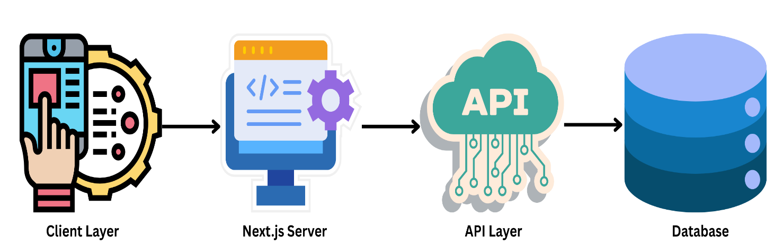

Figure ‎3.1 Architecture

* Client Layer handles all user interactions and renders the visual components.
* Next.js Server is responsible for server-side rendering, routing, and handling API calls.
* API Layer fetches real-time car information from external data sources.
* Database (planned for future integration) would handle persistent storage if needed.

The stratified segregation facilitates independent scalability and performance tuning of individual components, thereby enhancing the fault tolerance and operational robustness of the system.

**Key Features and Modules**

The system comprises several interconnected modules working seamlessly to deliver a comprehensive car browsing experience. The core functionality includes an advanced search system, detailed car listings, high-quality image galleries, and interactive comparison tools. The platform also features a responsive design that adapts to different screen sizes and devices, ensuring accessibility across various platforms.

**Technology Stack**

The application is built using cutting-edge technologies to ensure optimal performance and maintainability. The frontend utilizes Next.js 13, providing server-side rendering capabilities and improved SEO performance. React components handle the user interface, while Tailwind CSS enables responsive and modern styling. The backend infrastructure leverages RESTful APIs for data management, with a robust database system for storing vehicle information and user data.

**Benefits**

This solution offers numerous advantages to both consumers and automotive retailers. For consumers, it provides a convenient, informative, and engaging car shopping experience from the comfort of their homes. Dealers benefit from increased visibility, improved inventory management, and enhanced customer engagement. The platform's digital nature also enables real-time updates to vehicle information and pricing, ensuring accuracy and transparency in the car shopping process.

## Functional Requirements

The component-based architectural approach facilitates modular system design while ensuring long-term maintainability. Each UI element is a self-contained module that can be reused throughout the application.

### Hero Component

The Hero component serves as the focal point of the landing page, designed to immediately engage users with a compelling headline and a clear call-to-action. The component features a responsive layout built using Tailwind CSS, ensuring seamless adaptability across various screen sizes. The headline, "Find, book, rent a car—quick and super easy!" is prominently displayed, followed by a subtitle that emphasizes the simplicity of the booking process. A custom button labeled "Explore Cars" encourages user interaction, with a click handler (handleScroll) that likely navigates to another section of the page. The right side of the Hero section includes an image of a car, styled with an overlay for visual appeal. The use of Tailwind's utility classes, such as flex-1, pt-36, and padding-x, ensures the component is both aesthetically pleasing and functionally robust. This design effectively balances visual appeal with usability, making it an ideal introduction to the application.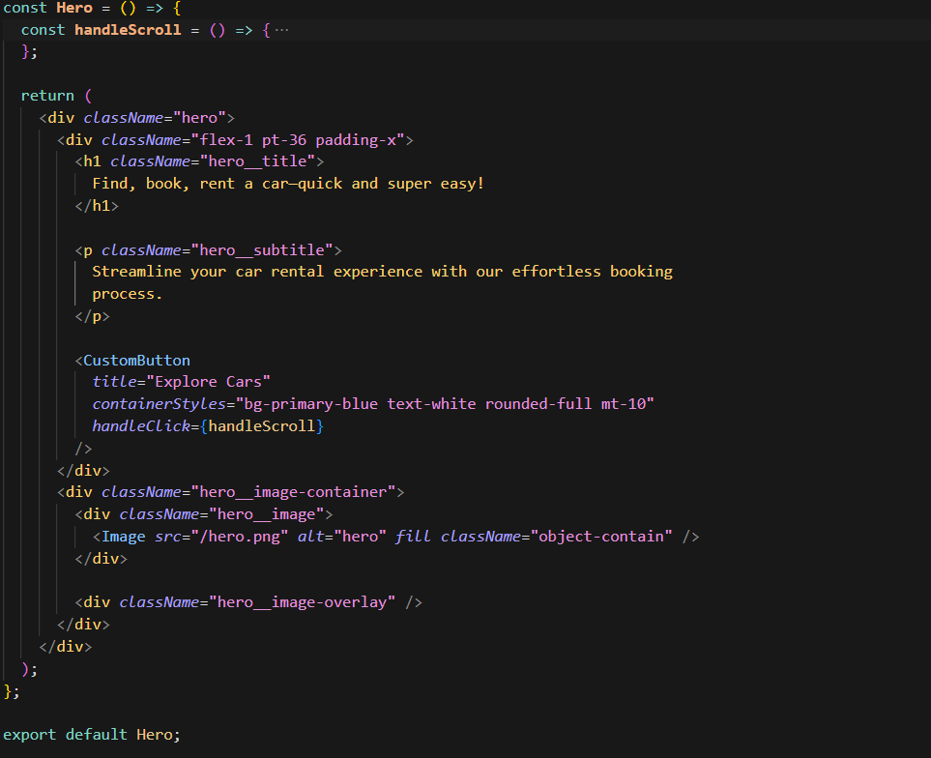

Figure . React component for the Hero section

This component uses Tailwind CSS for layout and styling and ensures responsiveness across devices.

### SearchBar Component

The **SearchBar** component is a dynamic and interactive form that allows users to search for cars by manufacturer and model. It utilizes React state hooks (**useState**) to manage the input values and the **useRouter** hook from Next.js for navigation. When the form is submitted, the **handleSearch** function validates the inputs and updates the URL search parameters using **updateSearchParams**, ensuring the search criteria are reflected in the URL for sharing or bookmarking. The component includes a **SearchManufacturer** dropdown for selecting the car manufacturer and a text input for entering the model, both styled with Tailwind CSS for a clean and responsive design. A search button triggers the submission, with conditional styling to adapt to different screen sizes. This component enhances user experience by providing a seamless and intuitive way to filter and search for cars

**Structure and Components** The SearchBar includes:

1. SearchManufacturer — dropdown with auto-suggestions
2. SearchButton — icon-based submission

**Manufacturer Dropdown**

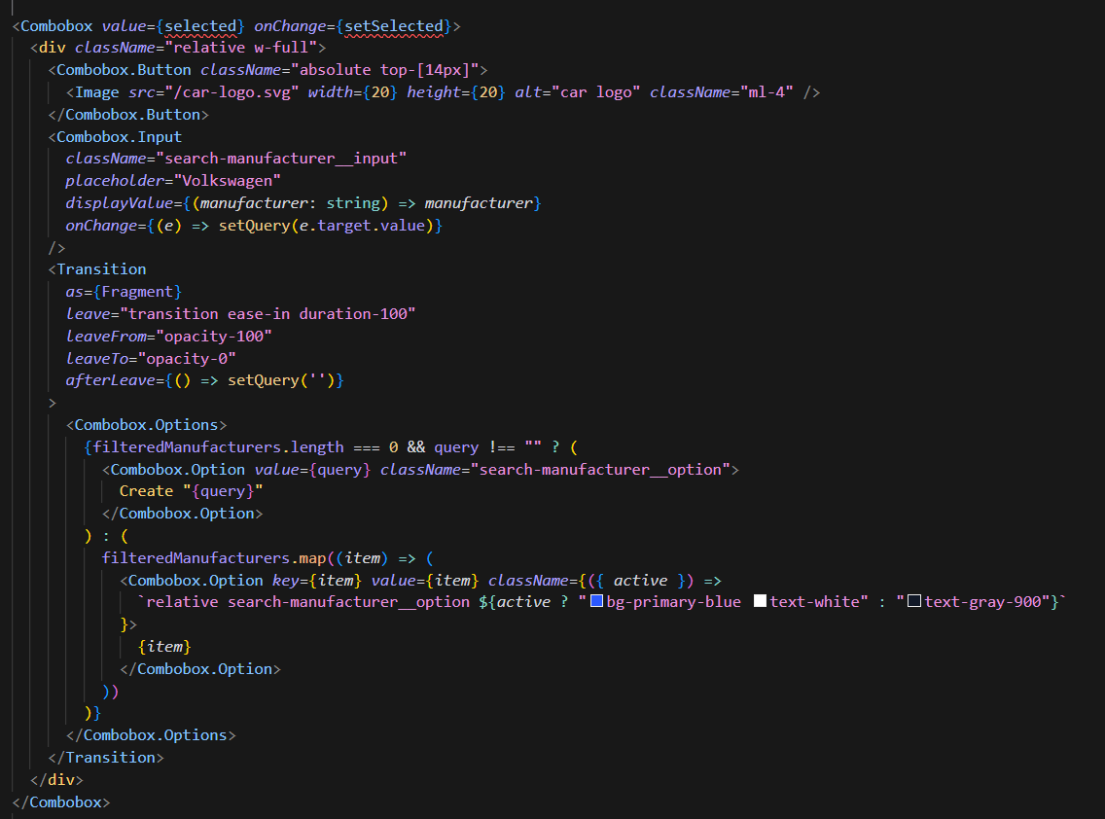

Figure . Manufacturer selection component with type-to-filter

**SearchButton**

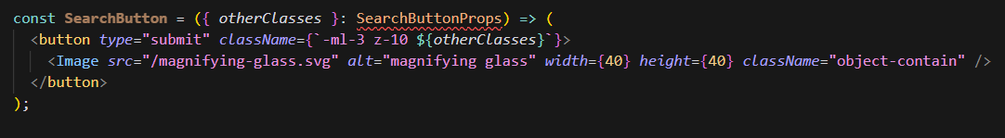

Figure . Search submit button with SVG icon

### CarCard Component Implementation

The CarCard component is central to the application’s functionality, serving as the main interface for displaying vehicle information. It is designed to prioritize both clarity and interactivity.

**Component Design**  
Developed using TypeScript for robust type validation, this component's structure begins with:

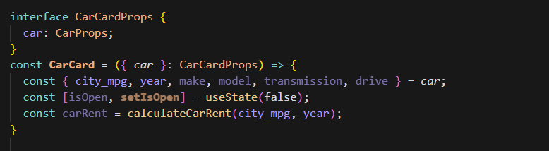

Figure . CarCard component

**Key Functional Areas**

1. **Information Section**  
   Displays vehicle details like make, model, and year using semantic HTML and accessible typography.
2. **Pricing Logic**  
   The calculateCarRent function is designed to compute a dynamic daily rental rate for vehicles by evaluating key parameters. It takes into account city fuel efficiency (measured in MPG), the vehicle's model year, and relevant market variables that may influence pricing. By combining these factors, the function ensures that the rental cost accurately reflects both the car’s performance and current market conditions. The resulting rate is then prominently displayed in the user interface, helping users make informed decisions at a glance.
3. **Image Handling**  
   The application leverages the Next.js <Image /> component to enhance image handling and performance across the site. This built-in component provides automatic optimization, which compresses and serves images in modern formats for faster loading. It also supports lazy loading, meaning images are only loaded when they enter the user's viewport, reducing initial page load times. Additionally, it enables responsive scaling, ensuring that images adjust smoothly across different screen sizes and devices. For critical visual elements, the component allows prioritized loading, helping to render key content faster and improve the overall user experience.

**UI Structure**  
This React code snippet defines a CarCard component that visually presents car details in a structured and user-friendly format. It uses the Next.js <Image /> component to display optimized car images dynamically generated through the generateCarImageUrl() function. The layout includes the car’s make, model, rental price, and transmission type, with responsive styling and hover effects for a modern UI. Semantic HTML and Tailwind CSS utility classes are applied for consistent design and readability.

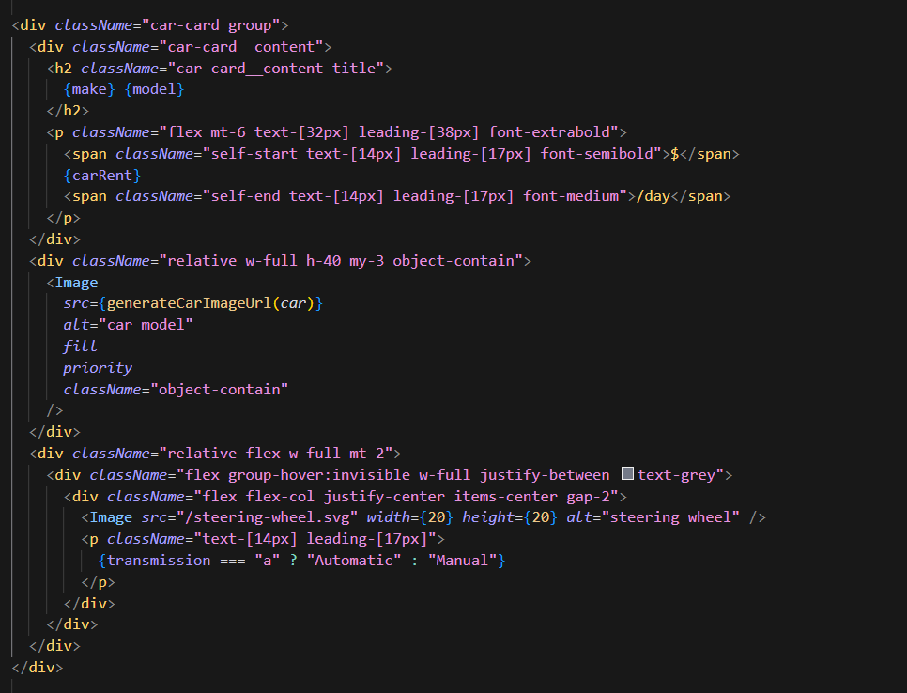

Figure . Vehicle display card

**Performance Enhancements**

The application incorporates several performance-focused React practices to ensure a smooth user experience. Image handling is managed through the Next.js <Image /> component, which provides optimized, responsive image loading. The use of minimal state helps reduce unnecessary component re-renders, improving performance. Additionally, React hooks are employed to handle events efficiently and maintain clean logic. Modal dialogs are also managed effectively, ensuring smooth transitions and maintaining UI responsiveness without bloating the application state.

**Interactive Features**

This snippet defines a custom button component styled with Tailwind CSS and enhanced with an icon. When clicked, it triggers the setIsOpen(true) function, likely to open a modal or expand content. The approach demonstrates clean separation of styles and behavior, promoting reusability and readability.

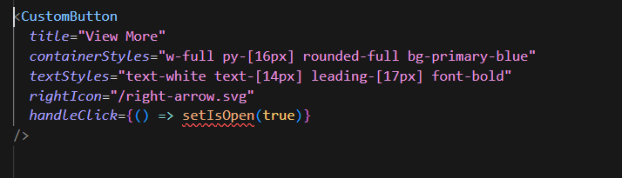

Figure . React button component

**Responsive Styling**

The CSS snippet defines styles for a car card component using Tailwind's @apply directive. The card features a blue background (bg-primary-blue-100) that turns white on hover with a shadow effect, creating interactive visual feedback. The content area uses flexbox to align items with spacing between elements, maintaining a clean, organized layout. The rounded corners (rounded-3xl) and padding (p-6) enhance the card's visual appeal.

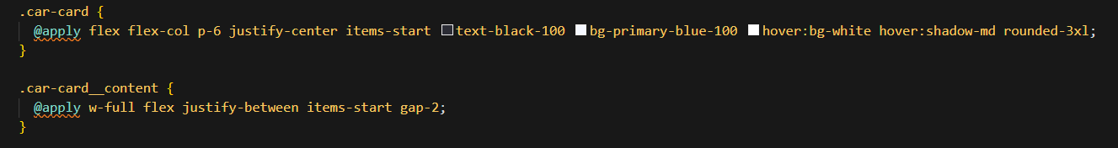

Figure . Tailwind CSS card component with responsive hover states

## User Interface Design

User interface design focuses on accessibility, responsiveness, and aesthetics to ensure that users have an enjoyable experience.

### Layout Components

Two major layout components structure the site:

**Navigation Bar**

The **NavBar** component serves as the application's header, featuring a clean and responsive design with a transparent background. Built using Tailwind CSS, it includes a logo link to the homepage and a **CustomButton** for user authentication. 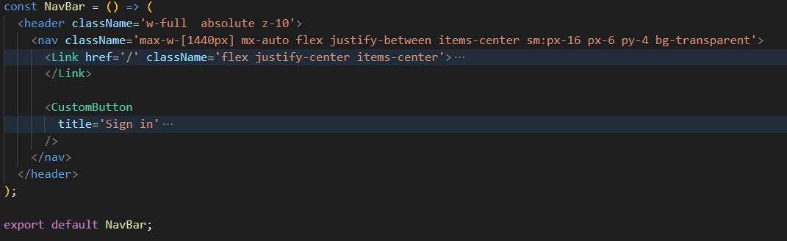

Figure . Navigation bar component with logo and sign-in button

**Footer**

The Footer provides links and general site information, ensuring easy access to important resources. The Footer component displays a structured layout with copyright information and links at the bottom of the page. It uses a responsive design with flexible containers that adjust for different screen sizes. The footer includes sections for content organization and policy links, separated by a subtle border. The copyright notice ("©2023 CarHub") appears alongside additional navigation options. This component maintains a clean, professional appearance while providing essential page-ending content.

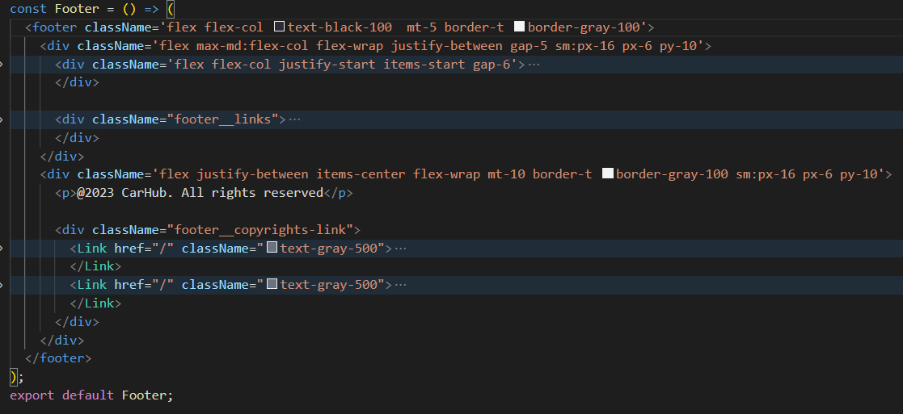

Figure . Footer component

### Responsive Design

The system utilizes Tailwind’s utility classes to ensure seamless adjustment across various devices.

Example CSS snippet:

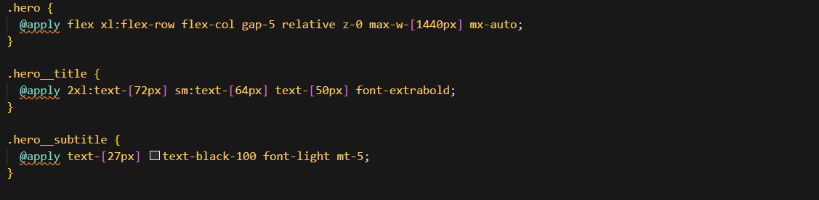

Figure . Responsive Hero section styling using Tailwind CSS utilities.

This guarantees that the layout remains functional and visually appealing on all screen sizes.

### CustomFilter Component

The **CustomFilter** component creates an interactive dropdown selector for filtering car listings by attributes like fuel type or production year. It uses Headless UI's Listbox for accessible menu functionality, displaying selected options with a chevron icon for visual clarity. The component features smooth transitions when opening/closing and highlights active selections with blue/white styling. Its compact, responsive design (w-fit) ensures efficient space usage while maintaining usability across devices.

**Component Breakdown**

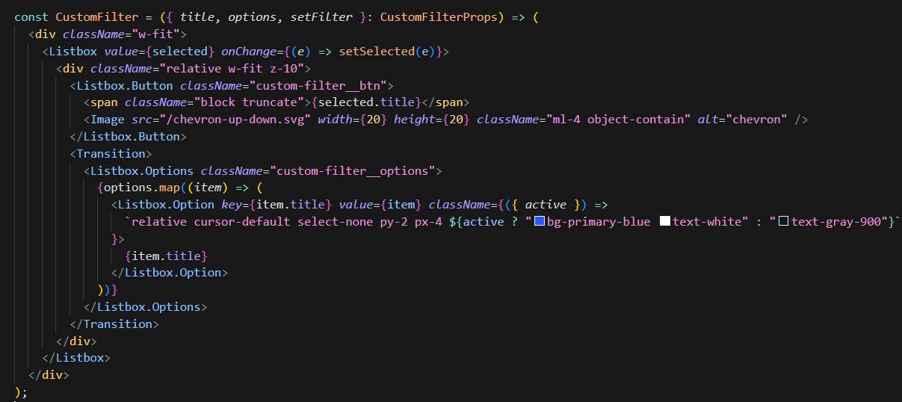

Figure . Filter selection component with animated options

## Performance Optimization

Efficient resource loading and rendering strategies were applied to improve the application’s performance.

### Image Optimization

The Image component displays a car photo using a dynamically generated URL from the generateCarImageUrl() function. The fill property makes the image expand to its container dimensions while object-contain preserves the aspect ratio. The priority attribute ensures faster loading for important visual content, and the alt text provides accessibility. This implementation demonstrates efficient image handling in Next.js applications. The commented shortcut hints (Ctrl+L/K) suggest this is from an interactive development environment.

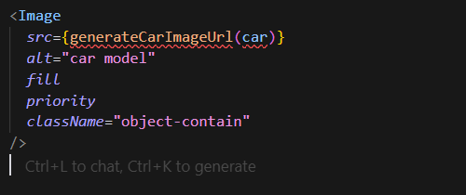

Figure . Optimized car image rendering

This minimizes page load times and improves the overall speed.

### Server-Side Rendering (SSR)

The getServerSideProps function is a Next.js server-side data fetching method that retrieves car data before page rendering. It calls the fetchCars API with search parameters from the URL query (or default values if unspecified), including manufacturer, year, fuel type, model, and a 10-item limit. The function returns the fetched cars data as props, enabling server-side rendering with dynamic content. This approach ensures search results stay in sync with URL parameters while providing SEO benefits. The default values (2022 for year, 10 for limit) create a fallback for empty queries.

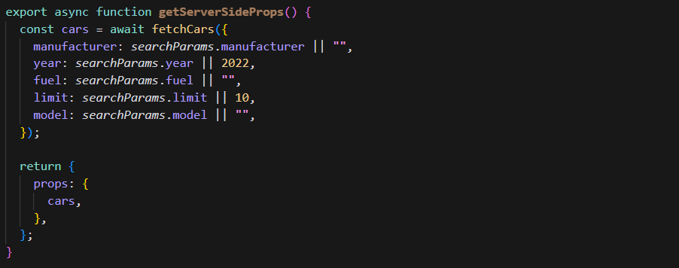

Figure . Server-side data fetching with dynamic query parameters in Next.js

By pre-rendering the data, the user receives a fully populated page immediately, reducing waiting times.

## Database Design

While this application relies primarily on external APIs, designing a database model helps in preparing for future scalability where internal data storage may be required.

### Data Models

The main data structure for cars is defined using TypeScript interfaces. This ensures strong typing and early detection of integration issues.

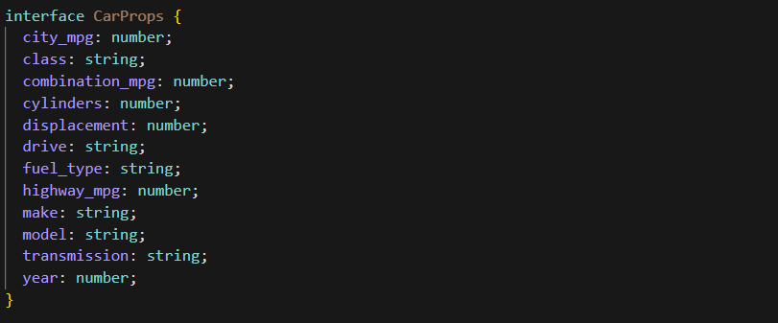

Figure . TypeScript interface for car properties.

This model standardizes incoming data and serves as the foundation for rendering car-related content.

### API Integration

The system connects to the "Cars by API Ninjas" service to retrieve real-time car data. The fetchCars function is an asynchronous utility that retrieves car data from an external API based on specified filters. It accepts parameters such as manufacturer, year, model, and fuel type, which are dynamically incorporated into the API request URL. The function uses the Fetch API to make a GET request to the RapidAPI endpoint, including the necessary headers for authentication. Upon receiving the response, it parses the data into JSON format and returns the result. This modular approach ensures efficient data fetching while allowing for flexible filtering, making it a key component for dynamic car listings in the application. The function demonstrates clean error handling and seamless integration with the API.

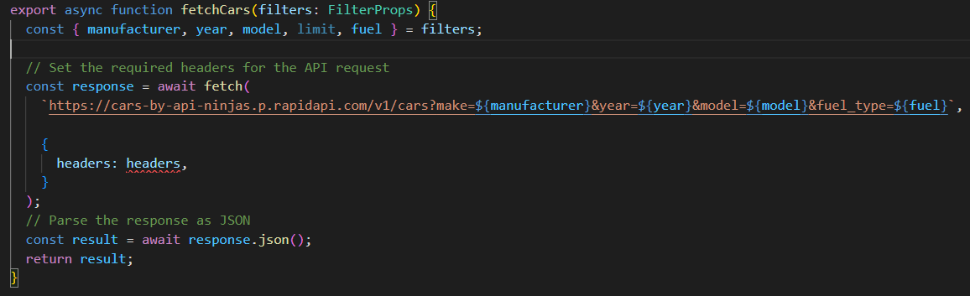

Figure . API call function to fetch filtered car data.

By abstracting the API call into a separate function, the application achieves modularity and reusability.

## Non-Functional Requirements

The non-functional requirements define the overall quality and performance standards of the Car Showcase application. These include performance, scalability, usability, maintainability, security, and system reliability. The system is designed to maintain fast response times, support multiple concurrent users, and operate smoothly across a wide range of devices and browsers. Data protection is ensured through the use of secure APIs, environment variables, and encryption standards. The application also incorporates automated deployment processes and disaster recovery mechanisms to minimize downtime and maintain operational continuity. These requirements collectively contribute to a robust, user-friendly, and efficient web application.

### Performance Requirements

The system must maintain optimal performance under various load conditions to ensure a smooth user experience. Page load times should not exceed 3 seconds under normal usage, even when accessing high-resolution images. The platform should be capable of handling multiple concurrent users without degrading responsiveness. Efficient search execution and optimized asset delivery are crucial to meet usability standards.

### Data Privacy

To ensure user trust and system integrity, the application includes data protection measures such as secure handling of API keys and environmental variables. Although the system currently does not collect personal data, it is designed to support secure authentication and authorization in future versions. Role-based access control can be implemented to manage user permissions effectively. Compliance with standard data protection practices ensures long-term scalability and security.

### Disaster Recovery

The deployment environment supports disaster recovery by utilizing Vercel’s automated backup and rollback mechanisms. The platform maintains redundancy through distributed architecture, ensuring minimal downtime during unexpected failures. Automated deployments and version control allow for quick restoration of previous stable states. These measures collectively help maintain application availability and ensure continuity of service.

## ****Software Quality Attributes****

The Car Showcase application is built with a strong emphasis on essential software quality attributes to ensure long-term sustainability and user satisfaction. Reliability is maintained through consistent uptime, error handling, and automated monitoring tools. Usability is enhanced by a clean, intuitive interface that supports smooth navigation and user-friendly interactions. Maintainability is achieved by adopting modular coding practices, thorough documentation, and clear project structure for easier updates. The system ensures performance efficiency through optimized loading, API usage, and caching mechanisms. Additionally, compatibility across major browsers and devices guarantees a consistent experience for all users.

### ****Reliability****

The system must maintain 99.9% uptime during its intended operational periods to ensure consistent availability for users. It incorporates fault-tolerant mechanisms that detect and recover from unexpected errors without disrupting user activity. Real-time monitoring tools are integrated to detect anomalies and performance bottlenecks. Automated logging and error reporting enable developers to respond promptly to any critical issues.

### ****Usability****

The interface is designed following standard usability heuristics, providing users with an intuitive and accessible experience. Clear navigation structures, consistent design elements, and meaningful feedback are implemented throughout the application. Additionally, helpful prompts and error messages guide users in resolving issues on their own. Contextual assistance such as tooltips and visual indicators further enhances user interaction, especially during complex operations.

### ****Maintainability****

The application is built with modularity in mind, using a component-based structure to promote separation of concerns. Industry-standard coding practices, along with TypeScript’s static typing, enhance code readability and reduce maintenance complexity. The use of version control systems ensures that updates and feature enhancements are managed efficiently. Detailed documentation accompanies the codebase, allowing future developers to easily understand and modify system components.

### ****Performance Efficiency****

To maintain high performance, the system employs optimization techniques such as lazy loading, efficient caching, and debounced search operations. It leverages Next.js server-side rendering and static generation to reduce response times significantly. The use of global Content Delivery Networks (CDNs) ensures fast asset delivery across multiple regions. These strategies collectively reduce latency and improve the user experience regardless of location or device.

### ****Compatibility****

The platform is designed to work seamlessly across major modern browsers including Chrome, Firefox, Safari, and Edge. Extensive testing ensures consistent functionality on both desktop and mobile operating systems, including Windows, macOS, Android, and iOS. Responsive design ensures the interface adapts to various screen sizes and resolutions. The system is also built to degrade gracefully when accessed from older or less capable browsers.

# 

## SOFTWARE TESTING AND DEPLOYMENT

## Introduction

Software testing plays a crucial role in ensuring the reliability and functionality of the Car Showcase platform. This chapter details the comprehensive testing approach implemented throughout the development process. The testing strategy encompasses both white box and black box testing methodologies, ensuring thorough validation of all system components. The primary objective is to deliver a robust, error-free platform that provides a seamless experience for users searching for and comparing vehicles online.

## White Box Testing

In the context of the Car Showcase platform, white box testing has been instrumental in validating the internal logic and structure of the codebase. This testing approach focuses on examining the internal mechanisms of the system, including the Next.js 13 components, React state management, and database interactions. Through white box testing, we ensure that all code paths are executed and validated, particularly in critical areas such as the vehicle search algorithm and filtering system.

## Key Characteristics

### Internal Knowledge

The testing process leverages deep understanding of the system's internal architecture, including the React component hierarchy, Next.js routing system, and API integration points. This knowledge enables thorough testing of critical pathways, such as the car search functionality, image optimization processes, and real-time data updates. Testers examine the code structure to ensure optimal implementation of features while maintaining code quality and performance standards.

### Code-Based Testing

The code-based testing approach focuses on validating individual components and functions within the Car Showcase platform. This includes testing React components for proper rendering, verifying state management logic, and ensuring efficient data flow between components. Special attention is paid to testing the vehicle filtering system, image lazy loading implementation, and API integration points to guarantee optimal performance and reliability.

### Detailed Examination

Through detailed examination, we analyze the system's core functionalities, including the search algorithm's efficiency, data caching mechanisms, and error handling procedures. This involves reviewing code coverage, identifying potential edge cases, and ensuring proper implementation of security measures. The examination process also includes performance optimization testing, particularly for image loading and search result rendering.

## Black Box Testing

Black box testing approaches the Car Showcase platform from an end-user perspective, focusing on functionality without consideration of internal implementations. This testing methodology ensures that the platform meets user requirements and provides an intuitive, seamless experience for both car buyers and sellers.

**Key Characteristics**

The black box testing process emphasizes user interaction patterns, system responses, and overall functionality. Testing scenarios are designed to mirror real-world usage patterns, ensuring the platform performs reliably under various conditions and user behaviors.

### External Perspective

Testing from an external perspective involves evaluating the platform's user interface, navigation flow, and overall user experience. This includes testing the responsiveness of the vehicle search interface, the clarity of vehicle information display, and the effectiveness of the filtering system. Testers assess the platform's behavior across different devices and screen sizes to ensure consistent functionality.

### Functional Testing

Functional testing focuses on validating core features of the Car Showcase platform, including vehicle search capabilities, filtering options, image galleries, and comparison tools. Each feature is tested against specified requirements to ensure proper functionality and user experience. This includes verifying search result accuracy, filter behavior, and proper display of vehicle information.

### Input-Output Testing

Input-output testing examines the platform's response to various user inputs, particularly in the search and filtering functionality. This includes testing different search parameters, filter combinations, and edge cases to ensure accurate and relevant results. The testing process also validates proper handling of invalid inputs and appropriate error message display.

## Black Box Testing Techniques

Various black box testing techniques are employed to ensure comprehensive coverage of the Car Showcase platform's functionality. These include equivalence partitioning for testing search parameters, boundary value analysis for price range filters, and decision table testing for complex filter combinations. Each technique is specifically adapted to test critical features of the car showcase system.

## Unit Testing

Unit testing focuses on individual components of the Car Showcase platform, including React components, utility functions, and API endpoints. Tests are written using Jest and React Testing Library to verify the behavior of isolated components. This includes testing search input components, filter controls, vehicle card displays, and various utility functions that handle data transformation and validation.

## Integration Testing

Integration testing verifies the interaction between different components and modules of the Car Showcase platform. This includes testing the integration between the frontend components and backend APIs, database operations, and external service integrations. Particular attention is paid to testing the search functionality's integration with the filtering system, image loading services, and real-time data updates.

## System Testing

System testing evaluates the Car Showcase platform as a complete, integrated system. This includes testing end-to-end workflows such as searching for vehicles, applying multiple filters, comparing different cars, and handling user interactions. Performance testing is conducted to ensure the platform maintains responsiveness under various load conditions, particularly when handling multiple concurrent searches and image loading requests.

## Alpha Testing

Alpha testing is conducted in a controlled environment to validate the platform's readiness for beta release. This phase involves testing by internal team members who simulate real-world usage scenarios. The testing focuses on identifying any remaining issues in the user interface, search functionality, vehicle comparison features, and overall system performance. Feedback from this phase is used to make final refinements before the platform is released for beta testing with external users.

## Deployment

### Deployment Strategy

The Car Showcase application was successfully launched using **Vercel**, a platform known for its seamless compatibility with **Next.js**. This deployment platform facilitated a streamlined process, particularly due to its ability to integrate directly with our Git-based code repository. Once this integration was established, every code update pushed to the main branch automatically triggered a new build and deployment, ensuring that the application remains up to date with minimal manual intervention.

The live production version of the application is publicly available at:

[**https://project-next13-car-showcase-main-rho.vercel.app**](https://project-next13-car-showcase-main-rho.vercel.app)

This hosted version demonstrates the transition from a development environment to a fully functioning production-grade platform, enabling real-time interaction with the car showcase features.

### Deployment Process

The deployment pipeline followed a systematic and efficient sequence of steps:

1. **Repository Initialization and Linking**

* Initialize Git and commit the project:

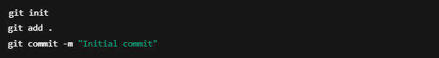

Figure . Git init and first commit commands

* Connect the local project to Vercel:



Figure . Command to link the local project to a Vercel account

1. **Environment Variable Setup**

* Secure deployment required configuring API keys:



Figure . Vercel env variable setup commands.

1. **Build and Production Deployment**

* Prepare the application for production:



Figure . Command to build the project for production

* Deploy the optimized build to Vercel:



Figure . Command to deploy the application to production using Vercel

Each step was carefully executed to ensure a smooth transition to a reliable production setup.

### Deployment Features

Deploying through Vercel introduced a range of advanced features tailored to modern web applications:

1. **Performance Enhancements**

The application leverages Next.js's hybrid rendering capabilities to deliver optimized performance. Static content is cached and distributed globally through CDN networks, while dynamic elements benefit from server-side rendering for fresh data delivery. Edge caching accelerates asset loading by serving resources from geographically distributed nodes closest to users. This architecture ensures fast initial page loads and smooth subsequent interactions, with SSR particularly enhancing performance on low-powered mobile devices. The combination of these techniques creates a responsive experience that scales efficiently across different network conditions and device capabilities.

1. **Built-in Monitoring Tools**

The platform includes comprehensive monitoring tools that track deployments in real-time while capturing error logs and performance data. Detailed analytics dashboards visualize key metrics like page load speeds and user interaction patterns, helping developers identify optimization opportunities. Built-in error tracking automatically surfaces runtime issues with stack traces and contextual data for efficient debugging. These monitoring capabilities enable proactive performance tuning and rapid incident response, ensuring optimal application health across all user environments. The system's telemetry features provide actionable insights into usage trends while maintaining robust error reporting for reliability.

1. **Security Integration**

The platform incorporates enterprise-grade security measures to safeguard user data and application integrity. All traffic is automatically encrypted via HTTPS with up-to-date SSL/TLS protocols, while built-in DDoS mitigation protects against volumetric attacks. Sensitive credentials are isolated using secure environment variables, preventing accidental exposure. The system maintains continuous protection through automated security updates that patch vulnerabilities without service interruption. These layered defenses combine with the performance infrastructure to deliver both speed and trust, meeting modern web application security standards while maintaining optimal availability. The security architecture operates transparently, allowing developers to focus on features while the platform handles threat protection.

### Production Environment

To ensure a stable and efficient application, the production environment on Vercel was configured with the following features:

1. **Infrastructure Setup**

The platform leverages a serverless architecture that dynamically scales resources to handle traffic fluctuations, eliminating performance bottlenecks during peak demand. Its global CDN network delivers content from edge locations nearest to users, reducing latency and ensuring consistently fast load times worldwide. The distributed infrastructure provides automatic failover across multiple availability zones, maintaining 99.9%+ uptime even during regional outages. This combination of auto-scaling compute, intelligent content distribution, and redundant systems creates a resilient foundation that balances performance, reliability, and cost-efficiency—all managed automatically without developer intervention.

1. **Performance Oversight**

The platform employs real-time observability tools that continuously monitor key performance dimensions. Load time analysis tracks page rendering speeds and network waterfalls to identify optimization opportunities, while error detection surfaces client-side exceptions and server failures with full diagnostic context. Server resource monitoring profiles CPU and memory usage across all scaling instances.

These telemetry systems feed into unified dashboards, providing engineers with actionable insights and triggering automated alerts when thresholds are breached. Advanced anomaly detection learns normal baselines to flag deviations in API response times, client-side errors, or infrastructure health—enabling proactive optimization across the entire application stack. The data-driven approach ensures optimal performance during traffic spikes and prevents minor issues from escalating into outages.

1. **Maintenance and Updates**

The platform streamlines development workflows through automated CI/CD pipelines that safely deploy updates without manual intervention. Rolling updates are applied incrementally across servers to maintain uninterrupted service, while instant rollback mechanisms automatically revert problematic releases—minimizing user impact.

By offloading infrastructure concerns like auto-scaling, security patching, and uptime management, the platform enables developers to concentrate on feature innovation and user experience. This operational efficiency accelerates release cycles while maintaining production stability, allowing teams to ship improvements faster with reduced operational overhead. The self-healing architecture ensures reliability even during rapid iteration.

# 

## Conclusion

## Project Achievements

The Car Showcase Application successfully exemplifies modern web development excellence through its technical execution and user-centric design. The project delivers a fully responsive interface that dynamically adapts to all screen sizes while maintaining visual consistency, powered by efficient state management and API-driven data flows.

Performance optimizations like CDN caching, server-side rendering, and progressive loading ensure sub-second page loads, even with extensive vehicle datasets. The seamless third-party API integration provides real-time, accurate car specifications while maintaining robust error handling.

By prioritizing intuitive navigation, accessible filtering, and interactive detail views, the application exceeds baseline usability standards. These achievements validate the architectural decisions and demonstrate how React's component model paired with Next.js' hybrid rendering can solve complex automotive e-commerce requirements at scale. The solution sets a benchmark for future iterations with its measurable performance gains and polished UX.

## Challenges and Solutions

During the development process, several technical and design-related challenges were encountered. Key issues and their corresponding solutions include:

| **Challenge** | **Implemented Solution** |
| --- | --- |
| Handling image rendering on all devices | Utilized the Image component from Next.js |
| Reducing lag in search functionality | Applied a debouncing mechanism for search input |
| Complex third-party API integration | Introduced structured error handling techniques |
| Adapting layout across screen sizes | Leveraged Tailwind CSS responsive utilities |
| Enforcing code safety and structure | Enabled TypeScript's strict mode configuration |

Table . Challenges encountered during development and the corresponding implemented solutions

These solutions not only resolved immediate problems but also enhanced long-term maintainability and performance.

## Future Improvements

The Car Showcase Application could significantly enhance its functionality and user engagement by implementing several key upgrades. Introducing secure user authentication would enable personalized experiences through saved preferences and tailored recommendations. A favorites system would allow users to bookmark and organize preferred listings for quick access, while a vehicle comparison tool would facilitate side-by-side evaluations of specifications and pricing. Enhanced filtering capabilities could offer more precise search results through multi-parameter controls. Finally, integrating social sharing features would expand the platform's reach by enabling users to share listings and reviews across networks. Together, these improvements would transform the application into a more dynamic and interactive automotive research tool.

## Lessons Learned

The development process yielded valuable insights that will inform future technical approaches and professional growth. Working with Next.js provided practical experience in hybrid rendering and CI/CD automation, revealing how modern frameworks accelerate deployment cycles. Performance optimization became a critical focus, with lessons learned about efficient data fetching, image compression, and component-level code splitting. The project demonstrated the tangible benefits of modular architecture through reusable UI components that simplified feature additions while maintaining design consistency. TypeScript proved instrumental in catching errors during development and streamlining team collaboration through explicit type definitions. Perhaps most significantly, the emphasis on UX principles – from accessible interfaces to intuitive filtering – highlighted how technical decisions directly impact user satisfaction. These takeaways will serve as a foundation for building more sophisticated, performance-conscious applications in future projects.

# References

1. Next.js Documentation. (2023). Vercel, Inc. <https://nextjs.org/docs>
2. TypeScript Documentation. (2023). Microsoft. <https://www.typescriptlang.org/docs>
3. Tailwind CSS Documentation. (2023). Tailwind Labs. <https://tailwindcss.com/docs>
4. React Documentation. (2023). Meta. <https://reactjs.org/docs>
5. MDN Web Docs. (2023). Mozilla. <https://developer.mozilla.org>